**Test Plan Document**

**e-Care Clinicals Application**

Prepared by:

Yi Jiao

Song Li

Ming Jin

Sanaa Hajji

April 18, 2019

Table of Contents

1. INTRODUCTION 3

2. OBJECTIVES AND TASKS 3

3. SCOPE 4

3.1 System 4

3.2 Tactics: 5

4. TESTING STRATEGY 5

4.1 Unit Testing (alpha testing) 5

4.1.1 Definition: 5

4.1.2 Participants: 5

4.1.3 Methodology: 5

4.2 System and Integration Testing 6

4.2.1 Definition: 6

4.2.2 Participants: 6

4.2.3 Methodology: 6

4.3 Performance and Stress Testing 7

4.3.1 Definition: 7

4.3.2 Participants: 7

4.3.3 Methodology: 7

4.4 User Acceptance Testing (UAT) 8

4.4.1 Definition: 8

4.4.2 Participants: 8

4.4.3 Methodology: 8

5. TEST SCHEDULE 9

6. CONTROL PROCEDURES 9

6.1 Problem Reporting: 9

6.2 Change Requests: 9

7. FEATURES TO BE TESTED 9

8. FEATURES NOT TO BE TESTED 10

9. RESOURCES/ROLES & RESPONSIBILITIES 10

10. SCHEDULES 11

10.1 Test Plan 11

10.2 Test Case 12

11. DEPENDENCIES 13

12. RISKS/ASSUMPTIONS 14

13. TOOLS 14

14. APPROVALS 14

15. Appendix 15

# INTRODUCTION

This project is about testing a new E-care Clinical System for helping the nurses to provide better care to their patients. The functions of the e-care system are:

* Admit patients with two different types of insurances into the system:(Medicare/Medicaid) and commercial Insurances (Tufts, Blue Cross Blue Shields, etc.)
* The patient's demographic information will be sent to the OnBase System (or Document Imaging – DI) & the Spectra Labs upon admission. (Demographics are the personal information of the patients).
* Nurses record the treatments of the patients in e-Care.
* Nurses send the Lab Orders from e-Care to the Spectra Labs and then receive the Lab Results from Spectra into e-Care.
* E-Care sends the Treatments and the Lab Charges to the Financials application for billing purposes every night.
* The Financial application creates and sends claims to the Insurance companies for the Treatments and the Lab Charges for all patients and receives payments from them.
* The Financial System generates two Reports/Extracts daily:
* Daily Treatments Extract
* Daily Admission Extract

# OBJECTIVES AND TASKS

**Objectives**

Our objective is to test the functionality of each cell of the diagram below:

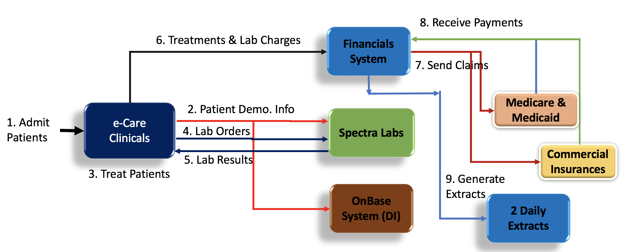

**Tasks**

There are parts in this test project, including:

1. Plan Test:
2. Review the Business requirement Document and Function Requirement in FSD.
3. Create initial test estimates.

B. Implement Test:

1. Config QA test environment.
2. Unit Testing
3. System and Integration Testing
4. Performance and Stress Testing
5. UAT
6. Batch Testing
7. Beta Testing
8. Regression testing

C. Problem Reporting:

Resolution of final defects and final build testing

# SCOPE

This test plan illustrates the integration of the system’s tests, also have the description of the system’s function of the E-clinic.

## System

The workflow of the system:

* Patient admission

the patient check-in to the Clinic, he will be registered if he is a new patient, if he is an existing patient, they will update his information like (Address, phone number, Emergency contact…)

* Patient Treatment

after the patient admission, the staff will check for the clinical flag then if the patient needs labs, they will send him to the lab section, after having the result of the lab, the patient will get the necessary treatment, and all the summary of his visit will be sent to the financial bureau.

* Financial system

The e-care admission sent all the treatment and labs to the financial system that will check for the patient information if he has one insurance or two insurance. Then they will submit a claim to Medicare or/and commercial insurance Report Generation and validation

all the patients and their treatments are on the Daily Report: daily Admission Report and daily treatment Report

## Tactics:

To Fulfill the test plan effectively we will follow these Tactics:

* Verify if the patient does Exist/or he is a new patient
* Verify if we can update a new client
* Check if the financially cleared flag
* Check the financial situation, if the patient has one or two insurance
* Check if we can send the patient’s lab request
* Check if we can get the patients labs
* Verify the report generation

# TESTING STRATEGY

## Unit Testing (alpha testing)

### Definition:

The first thing to do in this early stage is to review the functional requirement, to develop a comprehensive test case for each of the features. the next step we have to define specific goals for the alpha testing plan

### Participants:

The developer's team and the software QA staff.

### Methodology:

In the first phase, the developers and the project manager will be involved to review the requirement and go through the code to check the missing part along with the part that will crash and fix the bugs then they will hand it to the QA team to test it in their environment.

## System and Integration Testing

### Definition:

Our goal here is to verify the behavior of the entire system. the testing will be conducted in a complete and integrate the system to evaluate the functionality and if it satisfies the requirements. we will check the interaction between our different interfaces. (Admission, financial systems, Spectra (lab), and the claim system).

### Participants:

1. QA manager
2. QA team

### Methodology:

In this phase, we need to test all the features one by one:

* Admit a new or an existing patient into the system with a Financially Cleared flag set to YES. The patient should get admitted into the system.
* Admit an existing patient into the system with the Financially Cleared flag set to NO. The patient should be rejected.
* For a new patient that gets admitted a DI folder is created containing all of the Patient's Information. For an existing patient, the DI folder that already exists should get updated.
* For all new and existing patients getting admitted their demographic information is transmitted to the Spectra Labs
* Treat a new or an existing Patient with the Clinical Clearance flag = YES and with the Medicare/Medicaid as the insurance. The patient can use the Hep-Ran drug only
* Treat a new or an existing Patient with Clinical Clearance flag = YES and with Commercial insurance. The patient can use the Xer-Ran drug only.
* No treatments should be allowed for the new or a whose Clearance flag is set to NO.
* The Spectra Labs will then return the Lab Results to the Clinical System the same day.
* The Treatment and the lab Charges will be transmitted from the Clinical system to the Financial system for a new or an existing Patient with Medicare/Medicaid insurance.
* The Treatment and the Lab Charges will not be transmitted from the Clinical system to the Financial system for a new or an existing Patient with Medicare/Medicaid with the Clinical Clearance Flag = No (No treatment is done).
* The Financial system will open a Claim for the treatments and the Lab Charges for a new or an existing Patient with Medicare/Medicaid. The Claim is accepted, and a payment is sent back.
* The Financial system will open a Claim for the treatment and the Lab Charges for a new or an existing Patient for the Commercial Insurance. The Claim is accepted, and a payment is sent.
* Reports will become available the next day for all New and Existing patients who have been admitted and were treated with their Labs for the previous day. The reports are called: The Patients Report and the Treatments Report.

## Performance and Stress Testing

### Definition:

### Stress testing occurs to check the stability of our software system (E-clinic). This test will determine the system’s toughness and errors under a hefty load.

### Participants:

1. QA Manager  
2. Project Manager  
3. Senior Engineer  
4. Tester

### Methodology:

Identify how many nurses can log in simultaneously.

The stress testing methodology will involve the simulation to identify the vulnerabilities. In this case, we will use the automated testing; the UFT tool will be used to load the testing.

Firstly, we will test a heavy load on the system, using 200 patients in the beginning then check the stability of the system. The second step we will create between 200-400 patients and test simultaneity to make sure of the robustness of the system. also, we will put the maximum load at 300 demands for the lab’s user to spectra and check if will support this heavy load and identify the limit.

## User Acceptance Testing (UAT)

### Definition:

The UAT is the process of verifying if the solution works for the users, they called it (Beta testing), The purpose of the acceptance test is to confirm that the system is ready for operational use. During the acceptance test, end-users (customers) of the system compare the system to its initial requirements.

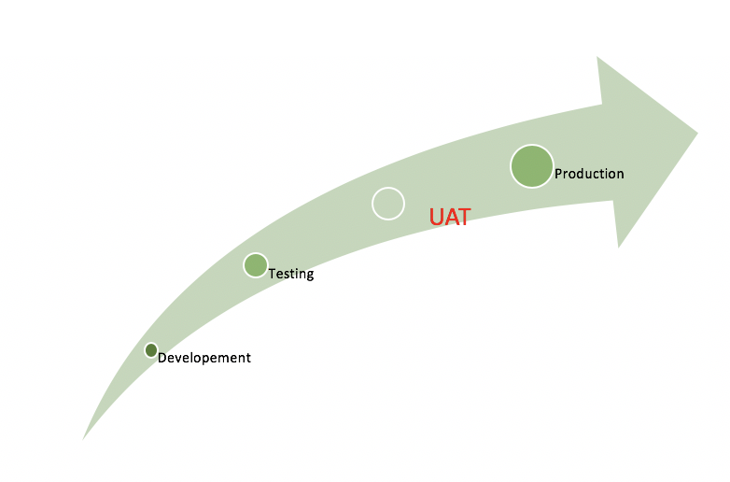

### Participants:

1. This testing will be taken by a subject-matter expert (SME).
2. The owner or client
3. End users

### Methodology:

UAT is one of the final stages in the project, it should be undertaken by the client solution under test and provide a summary of the findings for confirmation to proceed after trial or review often the UAT occurs before the Client accepts the new system. users of the system preform tests inline with will exist in real life scenarios. The UAT process is as the following image:

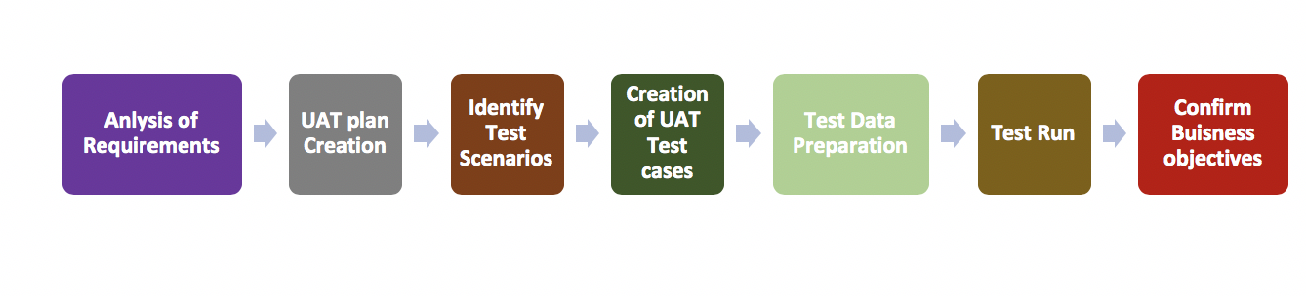

The testers will have the software similar to the materials the end user will have to provide testers with real-life scenarios.

# TEST SCHEDULE

All the test milestones are identified in the Software Project Schedule:

|  |  |  |
| --- | --- | --- |
| Task name | start | Comments |
| Review the Requirement document | 04/24/2019 |  |
| create a Test plan | 05/10/2019 |  |
| Unit testing | 06/15/2019 |  |
| Integration System | 07/20/2019 |  |
| User acceptance testing | 09/18/2019 |  |
| Regression testing | 10/01/2019 |  |
| Stress testing | 10/20/2019 |  |
| Release to the production | 12/24/2019 |  |

# CONTROL PROCEDURES

## Problem Reporting:

If any problem needs to be reported, please use the document attached in the Appendix-Exhibit 1.

## Change Requests:

If any changes are needed, please fill out the document in Appendix- Exhibit-2

# FEATURES TO BE TESTED

The features that will be tested is as following:

1. Identify all the software features and combinations of the software features that will be tested.
2. Verify if new/existing patients who are Financially Cleared get admitted
3. Check whether the DI folders are created/updated for patients after they get admitted
4. Check the financial situation, if the patient has one or two insurance
5. Check if we can send the Treatment and the lab charges to the financials application for billing purposes.
6. Check if the financial system will take care of the claims/payments with the insurance companies.
7. Verify if the Clinical System generates two reports (Daily Treatments Report and the Daily Labs Reports)

# FEATURES NOT TO BE TESTED

The features that will not be tested is as following:

**Patients Information:**

Basic personal information of patients, such as first name, last name, email, address, age, are not affect the later functions and is outside the scope of this project.

User interface: Since user interface should be tested during software development. So, for functional test, it should not be included.

# RESOURCES/ROLES & RESPONSIBILITIES

|  |  |  |
| --- | --- | --- |
| Role | Responsibility | Name |
| Project Test Lead | Responsible for oversight of testing on the project. Check procedure to guarantee the quality of deliverable | Sanaa |
| Testing Manager | Responsible for conducting quality assurance testing and executing on the test plan | Sanaa |
| Test Designer | Responsible for creating the test condition matrix, test scenarios | Ming Jin  Yi Jiao |
| Test Approver | Responsible for reviewing, validating and approving the test materials created by the Test Designer | Song Li  Sanna  Ming Jin |
| Tester | Responsible for executing the test scripts and reporting the results | Song Li  Sanna  Ming Jin  Yi Jiao |
| Reviewer | Responsible for reviewing reports from testers and determining what subsequent actions will be taken | Song Li  Sanna  Ming Jin  Yi Jiao |
| Developer | Responsible for programming the features of the application to match the requirements | N/A |
| Operations Staff | Responsible for providing the test environment | N/A |
|  |  |  |

# SCHEDULES

## Test Plan

There are totally 4 parts in this test plan, Test Planning, Testing, Post-Testing, and Reporting.

|  |  |  |  |
| --- | --- | --- | --- |
| Task Name | Start | Finish | Effort |
| Test Planning | 04/18/2019 | 04/20/2019 | 2d |
| Review Requirements documents |  |  | 0.5d |
| Create initial test estimates |  |  | 0.5d |
| Create the prototype of test plan |  |  | 1d |
| Task Name | Start | Finish | Effort |
| Testing | 04/21/2019 | 04/24/2019 | 4d |
| Config test environment |  |  | 0.5d |
| Unit Testing |  |  | 1d |
| System and Integration Testing |  |  | 0.5d |
| Performance and Stress Testing |  |  | 0.5d |
| UAT |  |  | 0.5d |
| Batch testing |  |  | 0.3d |
| Beta testing |  |  | 0.3d |
| Regression testing |  |  | 0.3d |
| Task Name | Start | Finish | Effort |
| Post-testing | 04/25/2019 | 04/28/2019 | 3d |
| Regression testing after developers review the defects |  |  |  |
| Task Name | Start | Finish | Effort |
| Problem reporting | 04/29/2019 | 04/31/2019 | 2d |
| Resolution of final defects and final build testing |  |  |  |

## 

## Test Case

* 1. **Test Scenarios _ 1**

Verify that a new patient will be admitted into the system if Financial Clearance Flag = yes, demographic information is created and sent to DI and SL.

|  |  |  |  |
| --- | --- | --- | --- |
| Test Step | Expected Results | Actual Results | Status |
| Go to URL = "ClinicalOnline.com" | clinical Online home page should be displayed | clinical Online home page should be displayed | Passed |
| Click "Verify Patient" button | The textbox should be displayed | The textbox should be displayed | Passed |
| Input patient's name in the textbox | Financial clearance status should be displayed | FC status should be displayed | Passed |
| Verify Finacial clearance flag status | Financial clearance should be YES or NO | FC status should be YES or NO | Passed |
| If Finacial clearance flag = YES, then add the patient into the system | The patient successfully admitted message should be displayed | The patient successfully admitted message should be displayed | Passed |
| Click the info tab to verify that a new DMI folder is created | Patient name_DMI folder should be displayed | Patient name_DMI folder should be displayed | Passed |
| Verify if DMI folder is sent to DI | Patient name_DMI folder should be displayed in DI | Patient name_DMI folder should be displayed in DI | Passed |
| Verify if DMI folder is sent to SL | Patient name_DMI folder should be displayed in SL | Patient name_DMI folder should be displayed in SL | Passed |

* 1. **Test Scenarios _ 5**

Verify if patients with flag = Medicare/Medicaid Insurance & Clinical Clearance flag = YES are treated with Hep-Ran only

|  |  |  |  |
| --- | --- | --- | --- |
| Test Step | Expected Results | Actual Results | Status |
| Click on the patient name from the patient table | The patient portal page should be displayed | The patient portal page should be displayed | Passed |
| Verify if IS flag = MI | "IS flag = MI" should be displayed | "IS flag = MI" should be displayed | Passed |
| Verify if CC flag = YES | "CC flag = YES" should be displayed | "CC flag = YES" should be displayed | Passed |
| Check the medication tab if the medicine is Hep-Ran | "Prescribed Medicine = Hep-Ran" should be displayed | "Prescribed Medicine = Hep-Ran" should be displayed | Passed |

# DEPENDENCIES

**Personnel Dependencies**: This project requires sufficient experienced testers to ensure the progress of the test and timely delivery.

**Technology Dependencies**: The test needs stable QA test environment and the configures of hardware and software need to be higher enough to support it for testing and guarantee the integrity of the test process.

# RISKS/ASSUMPTIONS

|  |  |
| --- | --- |
| Risk | Mitigation Strategy |
| Cannot perform every step of the test according to the scheduled time | Make sure the test environment has been set up. Conduct the initial test in the developing environment. |
| Changes to the functionality led to tests already written and test cases become useless  The whole test plan is a little complicated, tester should be familiar with many tools, if they want more professional | Confirm and figure out the functionality before testing. Make test cases easy to change.  Simplify the process of test. Make it more closely. |

# TOOLS

**Automation tool**

Unified Functional Testing (UFT) will be used for automated testing.

**Bug tracking tools**

[JIRA](https://www.atlassian.com/software/jira?&aceid=&adposition=1t1&adgroup=56999361780&campaign=1439934479&creative=338489531915&device=c&keyword=jira&matchtype=e&network=g&placement=&ds_kids=p34164036185&ds_e=GOOGLE&ds_eid=700000001558501&ds_e1=GOOGLE&gclid=CjwKCAjwzPXlBRAjEiwAj_XTEVjyA7I55-r3giqBFH1rTgp1KlE5wCj-CS8o-NkgdNRrkG2YA1EP7RoC5PYQAvD_BwE&gclsrc=aw.ds), [Bugzilla](https://backlog.com/lp/bug-tracking/?utm_source=adwords&utm_medium=cpc&utm_campaign=competitor_e&utm_term=bugzilla&gclid=CjwKCAjwzPXlBRAjEiwAj_XTEV4hhbUMDXhZSEFue-VnHzDGrHOEtECUmEt76wwUPxXcyOAUHef4wRoCGcQQAvD_BwE) and [Plutora](https://www.plutora.com/) Test will be used as bug tracking tools. These tools support the complete software testing process across all types of development methodologies from traditional Waterfall to Continuous Delivery approaches.

**Other tools**

[LoadRunner](https://www.microfocus.com/en-us/products/loadrunner-load-testing/overview) is used for performance and stress testing.

# APPROVALS

Specify the names and titles of all the persons who must approve this plan. Provide space for the signatures and dates.

Name (In Capital Letters) Signature Date:

1.

2.

3.

4.

# Appendix

**Exhibit 1**

**Problem Report**

|  |  |
| --- | --- |
| ID number |  |
| Name |  |
| Reporter |  |
| Submit Date |  |
| Summary |  |
| URL |  |
| Screenshot |  |
| Platform |  |
| Operating System |  |
| Browser |  |
| Severity |  |
| Assigned to | / |
| Priority |  |

**Description**

**Steps to reproduce**

**Expected result**

**Actual result**

**Notes**